Mirror.xyz Article

Decentralized Science and Gitcoin Grants
DeSci envisions a fair and equitable ecosystem for funding, creating, reviewing, crediting, storing, and disseminating scientific knowledge. The core idea is simple: transparency and decentralization lead to collaboration and progress in academia and beyond.

A Journey Through Rounds

Pre-DeSci
Initially emerging out of the Longevity Cause Rounds through GG12-GR14, the focus transitioned to support the broader DeSci ecosystem for GG15.

Keith Comito played a crucial role in the Longevity Cause Rounds on Gitcoin.

Although he did not steward the DeSci round directly, he provided valuable advisory support to the stewards.

His primary contributions included producing high-traffic articles and videos to promote Gitcoin and DeSci, thereby raising public awareness and engagement. Keith's media outreach included influential pieces on platforms such as CoinTelegraph and Lifespan.io, significantly boosting the visibility of the DeSci rounds.

His efforts ensured a successful transition and broad support for DeSci, helping to attract diverse projects and foster a collaborative environment. Through his advisory role and extensive publicity work, Keith helped shape the direction and success of the DeSci rounds on Gitcoin in its earliest beginnings.

The Genesis Round
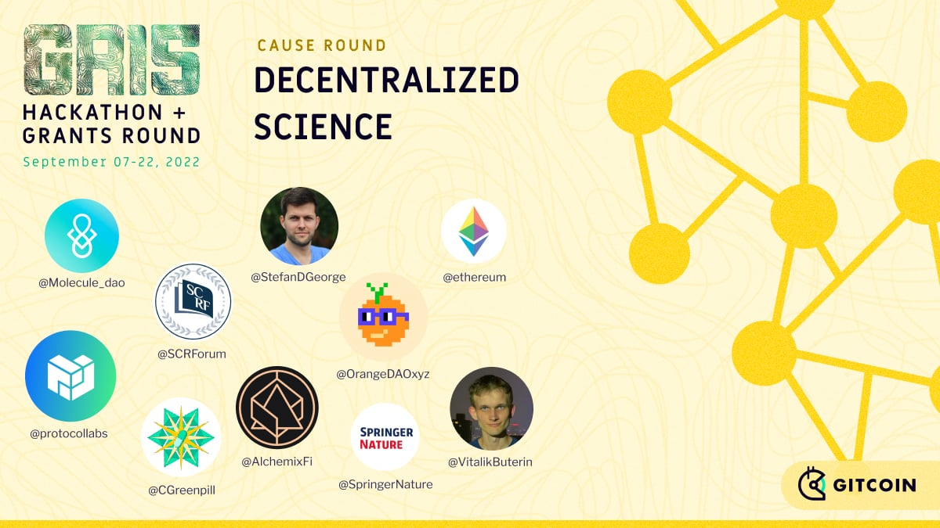

The inaugural DeSci Round in late 2022 as part of GG15, marked a pivotal moment for those advocating for decentralized approaches to scientific research and was a fundamental milestone for the DeSci community.
Vincent Weisser played a crucial role in initiating and executing the DeSci (Decentralized Science) Round during GR15 in September 2022. This effort was significantly supported by various key figures within the Gitcoin and DeSci communities. The notable contributors include Kydo, Shady, Erik, Eugene, Ben, Janine, Annika, Caro, J Ringo, Azeem, Carl, Vishnu, Sage, Umar, James, Scott, and Joseph Cook, among many others.
With the support of notable partners like Protocol Labs, Vitalik Buterin, Stefan George, Ethereum Foundation, SCRF (Smart Contract Research Forum), Molecule, Orange DAO, GreenPillCN, AlchemixFi, and Springer Nature, the genesis DeSci Round during GG15 galvanized significant support, attracting 2,309 donors who crowdfunded $67.9k to support over 82 projects. Leveraging matching contributions from various partners, the total pool exceeded $567k. This initial round had a significant impact on many projects that used the funds to do research, grow their communities, and develop new tools and services. As highlighted in the DeSci Landscape Analysis, it also showed the need for more consistent funding streams, market fit exploration, and the desire to understand what other projects were building, so it would be easy to collaborate and grow the ecosystem together.

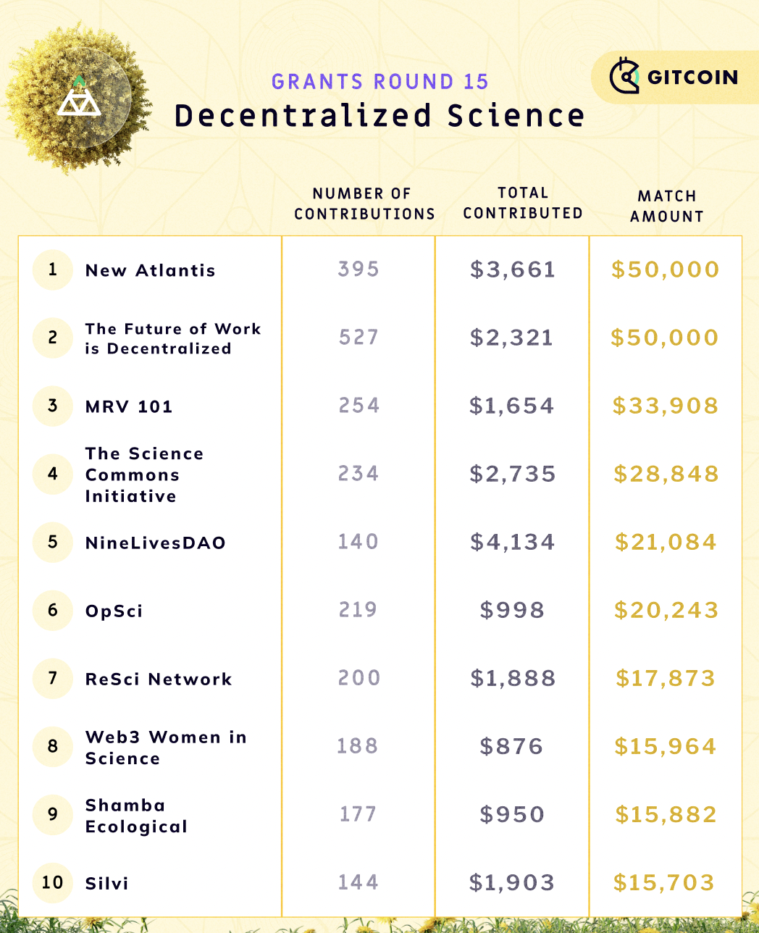

The GR15 round was organized in a centralized manner by Gitcoin and a select group of backers advocating for decentralized science. Despite this success, engagement dwindled, particularly amidst the challenges of the bear market.

Gitcoin Beta

Nonetheless, a community-led initiative emerged, spearheaded by Gitcoin’s previous DeSci lead, Boris Dyakov. Seeking to sustain the continuous funding of ecosystem growth in DeSci, Boris rallied previous sponsors to continue funding the efforts

An onchain election using the Jokerace platform was established to elect 4 additional round stewards from the DeSci community including Boris Dyakovb, Manuel Olariu from Deep Venture DAO, Sarah Rouse from SpaceBioDAO, Jelani Clark and Carolina Menchaca from DeSci World.

The DeSci stewards were elected to oversee decision-making and grantee review, securing sponsorship for 65 projects totaling $75K in the second DeSci round on Gitcoin.

In addition to $50,000 in funding from Gnosis Chain previously obtained by the Public Goods Funding workstream for a future DeSci round, the round operators raised an additional $25,000 from MoonDAO and $10,000 from Greenpill China for the GG Beta round.

According to the reportcard, the Beta round attracted 267 donors who crowdfunded $18.6k to support these 65 projects.

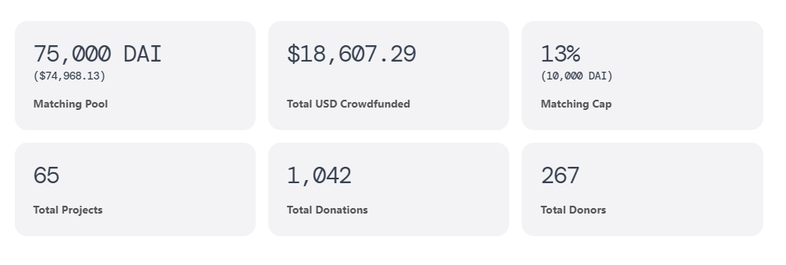
Similar to the Climate Round by Climate Coordination Network, it’s critical to maintain consistency with these bottom-up community-driven efforts because of the nature of a decentralized organization.

After this DeSci round in May 2023, Manuel Olariu continued to organize DeSci on Gitcoin while several community leaders stepped up to support this effort for sustainable ecosystem growth in Decentralized Science.

“Gitcoin Grants is an incredible Schelling point for early-stage DeSci projects to grow together.”

- Manuel Olariu

Celebrating Successes of GG20

With a matching pool of $25K, the #GG20 DeSci round supported 29 projects, attracting 250 individual donors who collectively contributed $8.5K in funding.
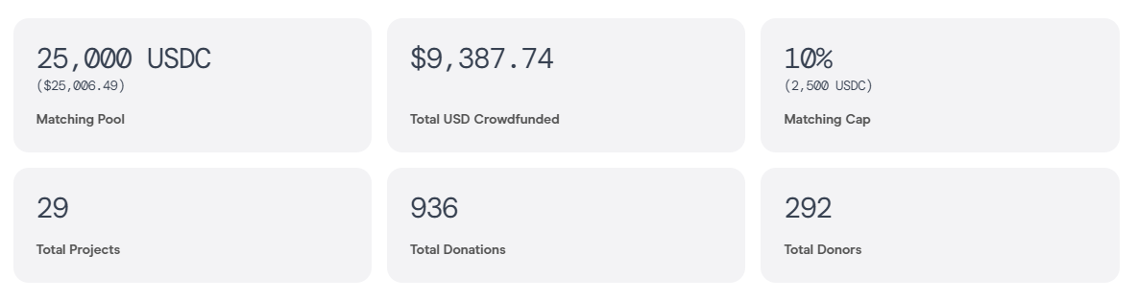
The matching pool was provided by previous sponsors, the Research Hub Foundation and Public Nouns. Notably, Jeffrey Koury from Research Hub Foundation and Sky Mine from the PublicNouns Community supported the round and paved the way for funding the GG20 matching pool.
What sets DeSci apart is its community-driven ethos. The DeSci round garnered the most community likes out of all the rounds in the Gitcoin Governance proposal for Community Rounds.
DeSci Operators stepped up to make this GG20 DeSci round a reality.
GG20 operators include Swift Evo from DeSci Asia, Maria Goreti Freitas from DeScier, Lana Ugrcic and Tomislav Mamic from Blocksplit, and Manuel Olariu.
Again, an onchain election on Jokerace took place including community voices in the process.
Four additional DeSci stewards were elected including Tomislav Mamic, Eva from AuraSci, Twone from Uncommons, Rodotriton from MesoreefDAO and Bhau from Archimedes Lever.
The Operators organized X spaces, managing everything from operations to fundraising and co-marketing efforts while stewards handled the continuous review of incoming grantees in the DeSci GG20 Round.
Swift Evo and Twone organized X spaces together with Uncommons and the Global Chinese Community for Public Goods to onboard DeSci communities in Asia.
The DeSci round in #GG20 was the first multi-language Gitcoin Grants round that engaged and enabled community members to submit projects in a variety of languages including English, Chinese and Spanish, e.g. Twitter Space about DeSci round in Spanish by DeSci LATAM GG20 DeSci projects introduction in Chinese by Swift Evo.
The DeSci Round Ops was also part of Let’s Grow 24/7 Live Broadcast organized by LetsGrowDAO and was mainly handled by Maria Goreti Freitas which enabled grantees to present their DeSci projects and find donors during the 14-day campaign spree.
Projects funded were aligned with the DeSci ethos and outlined in the eligibility criteria, spanned from critical infrastructure for the DeSci ecosystem to cutting-edge research initiatives, and community engagement projects that focus on spreading the narrative of DeSci across the globe. These projects could be categorized as: i) communities formation, ii) products and solutions, iii) education and iv) funding.
Despite being a relatively small community, the DeSci round boasted a solid core of grantees, operators, and supporters who have demonstrated unwavering commitment and enthusiasm.

The Road Ahead
As the DeSci Round evolves, experimenting with incentive structures and forging new partnerships is a priority. By implementing tools like Hypercerts and Karma GAP, the round seeks to enhance impact measurement for grantees, driving accountability and transparency.
In addition, the DeSci Round operators worked with DeSci Research Collective, composed of researchers from TalentDAO and the DeSci World on impact reports for past rounds.
As DeSci continues to grow, the stewards and operators envision the DeSci round becoming more than just a round—it aims to serve as an ecosystem governance framework, empowering stakeholders to shape the future of decentralized science. By fostering cross-organizational collaboration and embracing diverse perspectives, DeSci is poised to lead the charge in reimagining scientific research for the digital age.
For those passionate about advancing scientific inquiry and embracing decentralized approaches to knowledge creation, DeSci offers a unique opportunity to be part of a global movement.
The essence of a successful round extends beyond the mere allocation of funds; it lies in the invaluable exposure to a like-minded community and the opportunities for networking and collaboration it presents. The DeSci round exemplifies this ethos, serving as a catalyst for forging long-term, collaborative connections in the DeSci ecosystem.

Join us
Special thanks to all the contributors of this article: the DeSci operators, stewards, sponsors, the DeSci Research Collective and Lifespan!

If you want to learn more and get involved please follow the DeSci Round Ops on X and join the DeSci Gitcoin Telegram to stay up-to-date about the next DeSci Round on Gitcoin.

